**Devon Children’s Hearing Services**

**Working Group (CHSWG)**

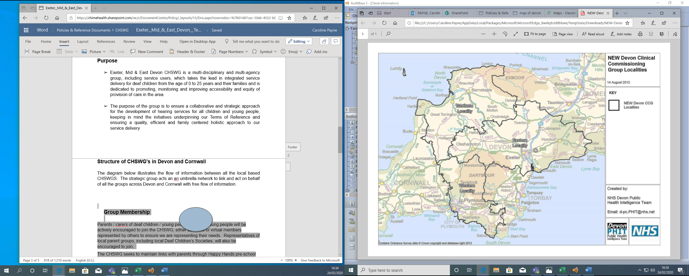

**Who are we?**

We are a group made up of health, education and social care professionals, volunteers and parents of deaf children who care about supporting deaf children and young people.

**What do we do?**

We work together to agreed ‘terms of reference’ to improve services for deaf and hearing impaired children and their families in this area.

**When & Where do we meet?**

We meet in the Exeter area, the venue may vary. We meet four times a year for 3 hours, on a Thursday morning.

**How can I be involved?**

Your views and experiences as Parents and Young People are important to us to help improve services – you can:

* Talk to any professional working with your child to share your views.
* Join the South West Every Deaf Child Matters Facebook Group *swedcm.weebly.com/****facebook****-****group****.html*
* Join our CHSWG group as either a regular member or request to attend a meeting
* View our minutes on the CHIME website or ask to join the circulation list

Contact: Benjamin Gillett Sarah Collinson

Telephone: 01392 402223 email: [sarah.collinson@ndcs.org.uk](mailto:sarah.collinson@ndcs.org.uk)

email: [ben.gillett@nhs.net](mailto:ben.gillett@nhs.net)

Look forward to hearing from you!

Reviewed Oct 2022